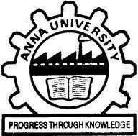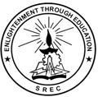**SRI RAMAKRISHNA ENGINEERING COLLEGE**

**COIMBATORE – 641 022**

**BONAFIDE CERTIFICATE**

**16EC253- MINI PROJECT 1**

Certified that this 16EC253 - Mini Project - I Report “**STOCK VALUE PREDICTION USING DEEP LEARNING”** is the bonafide work of **KARTHIK. K(1902132), NITHIN SOUNDAR. S. J (1902132), RITHICK ROSHAN.R(1902156)** who carried out the project under my supervision.

|  |  |
| --- | --- |
|  |  |
| **SIGNATURE** | **SIGNATURE** |
| **Mr. E. ESAKKI VIGNESWARAN, M.E.** | **Dr.M.JAGADEESWARI, M.E., Ph.D.,** |
| **Assistant Professor** | **Professor** |
| **Supervisor** | **Head of the Department** |
| Department of ECE | Department of ECE |
| Sri Ramakrishna Engineering College | Sri Ramakrishna Engineering College |
| Coimbatore- 641 022 | Coimbatore-641 022 |

**Submitted for the Mini Project Viva-Voce Presentation held on 03.07.2021**

|  |  |
| --- | --- |
|  |  |
| **INTERNAL EXAMINER** | **EXTERNAL EXAMINER** |
|  |  |
| **Mr.M.SELVAGANESH** | **Mrs.S.NAGARATHINAM,** |
| **Assistant Professor / ECE** | **Assistant Professor / ECE** |
| Sri Ramakrishna Engineering College | Kumaraguru College of Technology |
| Coimbatore- 641 022 | Coimbatore-641 049 |